**The taxonomic distinctness of UK Benthic function diversity : a macroecological perspective.**

**INTRODUCTION**

There has been growing interest in ways to quantify biological diversity emanating from a number of sources. Firstly, conservation and management pressures which are steadily being joined by ecosystem services pursuits are requiring functional and ecological evaluations of assemblages. These have been both in pursuit of indications of habitat degradation or for the evaluation of the ecological service (ranging from biomass productivity in plants to fish stock assessments). Now even habitats are investigated as surrogates for ecosystem functioning

These have also been joined by more theoretical undertakings, examining the contribution of habitat filtering vs divergent evolution to functional diversity. Petchey et al)

Macroecological investigations

Initially the problem was approached by relatively simple biodiversity metrics of species richness and various other indices which incorporate relative abundance of species information but it was soon appreciated that all species are not equal in the assessment of biodiversity for our purposes (May, 1990) and that the degree to which species are related affects both it’s response to the environment and it’s function and inherently limit the genetic diversity represent by these species. This lead to the development of taxonomic distinctness.

Taxonomic distinctness has been most used for the assessment of invertebrate communities for the evaluation of ecological status of sites primarily for the detection of environmental degradation in response to pollution and other stresses. The theory being that degraded sites have reduced taxonomic diversity. This implies that stressful conditions are difficult sections of ecospace that few taxonomic lineages have able to conquer and through habitat filtering, the index reflects the conditions which have selected for more related lineages.

It is calculated by first calculating a master dendrogram from a regional species pool, which represent the pool available for selection into a local assemblage. . When only presence / absence values are provided D* collapses to Δ+ which equates to the average path length connecting all species in the assemblages (Wahrick & Clarke, 1998). High values imply high average dissimilarity between species. This also allows the calculation of sd and a setting of confidence interval to which sites can be assessed for deviation from expected values for the given size of the local assemblage. Local assemblages are then compared to the master dendrogram and site specific Δ+ is calculated. Values of local Δ+ significantly lower than expected (ie below 95% confidence intervals) are considered relatively taxomically depleted. Equally, higher than expected Δ+ identifies relatively taxonomically enriched sites.

Benefits -> sampling effort independent, peculiar behaviour that addition of species can actually reduce assemblage Δ+ if the species is highly related to a species already in the assemblage.

**FD**

There are consistent lines of evidence suggesting that ecological assemblages from a variety of perspective is best approach with reference to it’s complexity and diversity of function. Whether estimating particular ecosystem services or trying to understand community assembly, a focus on taxonomic classifications has many pitfalls. From this arose a search to define the functional diversity of an assemblage. There are a variety of measures which have been developed, beginning with functional classification to predefined groups and now evolving towards development of continuous measures of eveness etc (reviews). One such measure is the dendrogram method of FD. It in fact has many similarities to the calculation of taxonomic diversity in that it calculates a dissimilarity but on traits. It also compares to regional dataset (see Petchey). It also provides information of the complexity of the partitioning of functional space in the form of the dendrograms.

The identities of membership to each node is available and so we calculated Δ+ for each node. We then calculated sd from expected Δ+ for the size of the cluster.

These can be effective and provided a surrogate for phylogeny which does have links to function. However it is weak in the face of taxonomic redundancy particularly at species (ref) and higher taxonomic level. (McGill, 2006)Taxonomy has been warned for it’s murkiness and in truth. Indeed it is an odd mixture of science and alchemy based. Also it is of course not immune to broader discussion about the species concept and the appropriate resolution at which any biodiversity assessment should be focusing on.

Nevertheless taxonomy is based on morphological characteristics and attributes that are fundamentally tied to traits used in functional diversity.

It has been noted that that the hierarchical partitioning of functional space might be inappropriate for some variables but at this macroecological scale we believe that a hierarchical structure would suit. Hierarchical organization of repeating modular elements is being uncovered at all organizational scales, even down to the system regulating trait gene expression.

Further more trait covariance (refs) point to paths of least resistance which partitions traits along axes of competing constraints.

Trait based approaches limited by trait data availability. In the marine environment the majority of work has focused on the benthos. Relatively sedentary

Bremner 2006 assessed the effect of trait variation in a limited number of species so is useful to assess applicability at lower level but expansion to larger numbers of species inevitably introduces limitations on the number of traits available and the patchiness of missing data will have a serious impact on statistical inference (Nakagawa & Freckleton, 2008). Tyler et al (2012) examined the feasibility of applying traits based approaches across an entire assemblage at a macroecological scale and identified extensive gaps in the UK benthos limiting their applicaton. Here we aim to extend this work in two ways. First to supplement trait data. Second to examine exactly how trade-offs in analysis imposed by the pattern of data availability affect functional and taxonomic assessment of a macroscale assemblage.

Additionally though we wish to assess theoretically the partitioning of functional space at this scale. So we also probe the structure of functional diversity for taxonomic signals.

At this scale, neutral dynamics are dampened and the examination of functional diversity becomes more akin to partitioning fundamental niche. Also issues of multimodality expressed differentially under local conditions are of reduced significance. This assemblage is of course compiled and does represent realised co occurrence. Some partitions may well related to large ecosystem types

**METHODS**

To examine the effects of s and t we performed a data experiment.

**Data**

*Species*

The initial dataset was based on the full data list compiled from Tyler *et al* 2012, Webb, 2009. This attempt to catalogue the state of biological knowledge on the UK benthos is fully described in Tyler, 2012 and while analysis in that paper was performed on a subset of the species list, here we have the full dataset. The dataset is based on the regional marine fauna of the UK which is especially well documented in terms of biogeography and taxonomy and restricted to benthic organisms due to their sedentary nature and because they have been the focus of previous assessments, both taxonomic (Clarke, sommerfield) and functional. Despite this Tyler identified significant gaps in the state of biological knowledge.

*Taxonomic data*

Data on the taxonomic classification of species was extracted from WoRMS[1] while any missing entries were supplemented from BIOTIC[2]

*Traits*

We have selected traits on a looser macroecological basis in that they are traits that affect fitness not just of individual populations but at a regional scale. So not just functional traits but also traits describing demographic properties of species. This is consistent both with general macroecological focus but also with calls to unify hutchinsonian niches with demographic considerations (Pulliam, 2000; Holt, 2009; Schurr *et al*, 2012). The whole of the strategy is under selection through time and space.

Trait data were supplemented in a number of ways:

* Empirical habitat affinity information was inferred from the survey locations.
* Trait data (especially maximum body size) from Hayward & Ryland (The Marine Fauna of the British Isles and NW Europe, vols I and II)
* Targeted library search in the National Marine Biological Library, Plymouth

Once all additional trait data were compiled, traits were examined for duplicate entries for traits of individual species. Maximum was preferred where available but there were occasions where mean or unknown were used.

Continues data were centered and scaled

Any trait based approach would require a certain amount of trait data so the species in the analysis were limited to those which have at least 4 traits. This resulted in an *s* x *t* matrix consisting of 198 species and 13 traits. The matrix was organized to reflect reducing numbers of species with complete cases of trait availability for an increasing number of traits (fig.1). Analysis then proceeded under 3 different conditions:

A – by varying both the number of species and number of species included in the analysis (fig. 1a)

B – by keeping the number of species constant (65) and varying the number of traits included in the analysis (1-9 traits)

C – by keeping the number of traits (4) constant and varying the number if species.

Notional Assemblages

Calculation of FD

For each assemblage / trait combination FD according to the method of Petchey and Gaston {Petchey:2002ug}was calculated. Briefly, first a distance matrix for the species in the assemblage was calculated based on the traits to be included in the particular step of the analysis. Because of the mixture of continuous (body size, lifespan, etc) and binary variables (all categorical variables) we calculated Gower distance {Gower:1971up} as it is more appropriate for mixed data like that {Podani:2006fo}. Because of standardization of continuous variables to the range [0,1], traits were equally weighted in their contribution to FD. We also set binary variables as asymmetrical. In essence this means than sharing zeros is ignored and species are considered similar only on sharing a particular trait not on sharing the absence of a trait {Legendre:2012uq}. This in effect limits the axes of variation included in each species pairwise distance calculation to the axis over which each species traits are expressed, ignoring axes (ie categories of a particular trait) over which no species trait expression occurs (check Friedman & Meulman, 2004). Species were subsequently clustered to produce a dendrogram using UPGMA algorithm {Podani:2006fo, Petchey:2007dw} (fig. 3a). FD is then the sum of the length of the branches in the dendrogram linking all species in the assemblage.

There has been ongoing debate regarding a standard procedure for calculating FD of different assemblages. Petchey & Gaston {Petchey:2002ug, Petchey:2007dw} advocate the use of the regional species list to produce a dendrogram of what could be considered regional functional diversity. FD of local assemblages is then the total length of branches connecting only member species. Podani & Schema (2006) on the other hand propose that individual dendrograms using data only on the member species of the assemblage be produced, local FD equating to the total branch lengths of each dendrogram. As we have produced separate FD dendrograms for each assemblage / trait combination it could be viewed that we are following the PS approach. However, the scale we are examining in more akin to the regional assemblage from which PG would then calculate local FD. Either way, the variation of either traits or species necessitates individual dendrograms for each combination. Our approach does not therefore constrain choice of approach for calculating local FD.

***Calculation of Δ+***

For each assemblage / trait combination, Δ+ of the assemblage was also calculated following the method of Clarke & Warwick {Clarke:1998um}. Similarly to the calculation of FD, a taxonomic distance matrix was computed for all species in the assemblage and a dendrogram produced. As Δ+ is calculated using only presence / absence data, it is the average path length connecting any two randomly selected species. Note here an important difference in how the two indices (FD & Δ+) are calculated. FD consists of the *sum* of branch lengths comprising the functional dendrogram whereas Δ+ represents the *average* taxonomic branch length connecting two species. While this attribute of Δ+ has been proposed as granting it independence of sample size (although see ref) it also endows it with the peculiar property of potentially reducing with the addition of closely related species to an assemblage. FD on the other hand will either increase or remain unchanged.

Clarke & Warwick (1998) also developed an approximation of a randomization test to detect differences in D+ from the expected D+ of a subset of the master assemblage of a given size. By deriving an appropriate variance formula, a confidence funnel of expected D+ as a function of species richness is produced against which samples can be compared. To probe the structure of the functional dendrogram for a taxonomic signal, the member species of each node were identified and D+ calculated for each (Δ*n*+). For each node, the expected D+ for a given random subset of the assemblage being investigated of equal size as well as the standard deviation were calculated (fig. 3b). This allowed the calculation of the standard deviation of each from expected D+ (indicating whether nodes were less taxonomically distinct (ie more taxonomically related) than would be expected by chance. For each assemblage / trait combination the mean node standard deviation from expected D+ (μ σΔ*n*+) was also calculated.

**RESULTS**

As expected, both s & t have a positive effect on FD. However the negative relationship between these two variables results in a humped shape in FD under condition A (fig. 5) with sharp declines in the ability of the analysis to capture FD diversity at both ends of the trade off scale. Using a large number of species but only a single trait to classify them results in the reduced power to differentiate functional partitions, much of the partitioning taking place further down the tree at low levels of dissimilarity (fig 2a). Conversely, using many traits to characterize a handful of species also results in reduced FD. Despite the high dissimilarity between species, the small number inevitably leads to low FD.

The individual effects of *t* & *s* can also be seen under conditions B & C respectively (fig. 6a & 6b). Increasing the number of species continuously increases FD up to the maximum. But it appears that the effects of the two variables might be additive as FD appears to be consistently lower for a given *s* than when analysis is performed with a larger number of traits. Increasing the number of traits used to characterize the functional diversity of a fixed number of species also appears to increase FD. However, for 65 species, the relationship appears to tail off at 6 traits, indicating that potentially for an assemblage of a given size, there exist a number of functional dimensions beyond which addition of more does not result in more complex partitioning of functional space. Without performing randomizations of variables we cannot know whether it is the identity of the redundant traits or whether there is indeed a rough number of axes across which FD can be characterized to it’s full extent. Additionally, performing the analysis under conditions B but varying the number at which *s* is held constant could help elucidate to what extent this trend is dependent on the size of the assemblage.

It must be noted that there is also the potential for lack of power in high trait dimensional analyses utilizing limited numbers of species. Every additional trait requires a disproportionate increases in observations to ensure valid results and following a suggested sample size of 2*t* (Formann, 1984) would leave analyses with more than 7 or 6 traits with increasingly less power under conditions A & B respectively.

Examining the behaviour of FD under realistic trade off conditions in A, reveals a broad interval of *s* x *t* space over which FD plateaus around the maximum value observed across any condition suggesting that in this interval, the trade off between species and trait inclusion may balance itself. Dendrograms also show relative stability in their broad structure throughout this interval. Interestingly, it also coincides with a trough in μ σΔ*n*+ indicating that FD is highest when the clustering encodes a strong taxonomic signal and this relationship is consistent throughout all conditions (fig. 7). While large assemblages appear to result in the most taxonomically clustered dendrogram structure, increasing numbers of traits also appears to reduce μ σΔ*n*+ so the trend is not purely driven by species richness.

Paragraph re TD in structure of trees

Overall, D+ varies very little across s – t combinations under conditions where the composition of assemblages is varied (A & C), and the apparent trends in fig. 5 & fig 6b are minimal as the plot scale only runs from 92-96. Indeed we are dealing with a highly taxonomically diverse assemblage with much of this diversity included even in the smallest assemblage containing 15 species and almost all phyla being present in the 46 species assemblage. While this indicates the potential limitation of using D+ for macroscale studies especially in such a taxonomically diverse system, it does indicate that the msDN+ are not driven by fluctuations in D+ as species composition of assemblages is varied. Indeed, an examination of D+ of species addition intervals showed variation, a strong trend between interval D+ and FD or msDN was not observed (data not shown).

DISCUSSION

**Table 1** Details of Trait data. The ordering from top to bottom reflects the sequence of inclusion of variables. Data availability indicates the number of species for which trait data were available and complete cases indicates the number of species for which data for the trait and all previous traits in the sequence are available.

|  |  |  |  |  |
| --- | --- | --- | --- | --- |
| **Trait** | **No. of spp** | **No.spp complete cases** | **Type** | **Range / modalities** |
| ***Body Size*** | 204 | 198 | Continuous | 0.4 - 90 cm |
| ***Movement Method*** | 195 | 188 | Categorical | burrower, crawler, floater, motile, permanent attachment, sessile, swimmer, temporary attachment, tube-dwelling |
| ***Feeding Method*** | 195 | 179 | Categorical | active suspension feeder, browser, deposit feeder, filter feeder, grazer, passive suspension feeder, predator, scavenger, surface deposit feeder, suspension feeder |
| ***Sociability*** | 183 | 164 | Categorical | colonial, gregarious, solitary, sometimes gregarious |
| ***Habitat*** | 133 | 120 | Categorical | demersal, epibenthic, epifaunal, epilithic, epiphytic, epizoic, infaunal |
| ***Diet*** | 120 | 101 | Categorical | algae, benthic organisms, detritus, macroalgae, meiobenthic organisms, micro-organisms, microalgae, omnivore, phytoplankton, plankton, sediment particles, suspended particles/material, zooplankton |
| ***Migration*** | 142 | 91 | Categorical | irregular/single migration, no evidence, non-migratory, regular |
| ***Reproductive Frequency*** | 116 | 79 | Categorical | annual, biannual, semelparous |
| ***Larval Feeding Strategy*** | 113 | 65 | Categorical | lecithotrophic, planktotrophic |
| ***Lifespan*** | 146 | 47 | Continuous | 1.5 - 60.5 |
| ***Reproductive Period*** | 111 | 46 | Categorical | episodic, protracted |
| ***Developmental Mechanism*** | 105 | 17 | Categorical | direct development, larval development, benthic larval development, pelagic larval development, oviparous, fission |
| ***Reproductive Timing*** | 91 | 15 | Categorical | 1 to 12 |

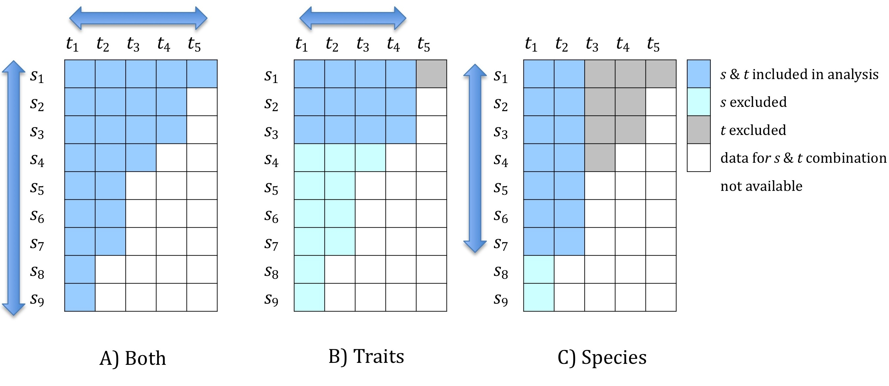

**Figure 1** Representation of ordering of species (*s*) and traits (*t* ) and selection procedure for each condition. A) Both species and trait number included in analysis is varied at each iteration resulting in all data being used in complete analysis B) Number of species included in analysis is held constant while trait inclusion is varied C) Number of traits is held constant while species are varied. Sequence of trait / species exclusion is fixed and follows ordering imposed by data availability.

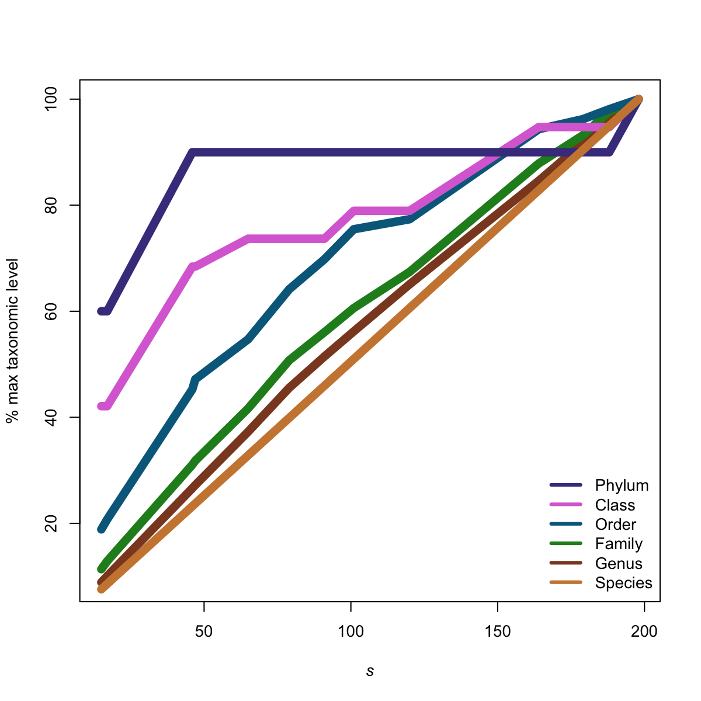

**Figure 2** Relationship between saturation of taxonomic levels represented in the full assemblage of 198 species as a function of increasing assemblage size (*s*).

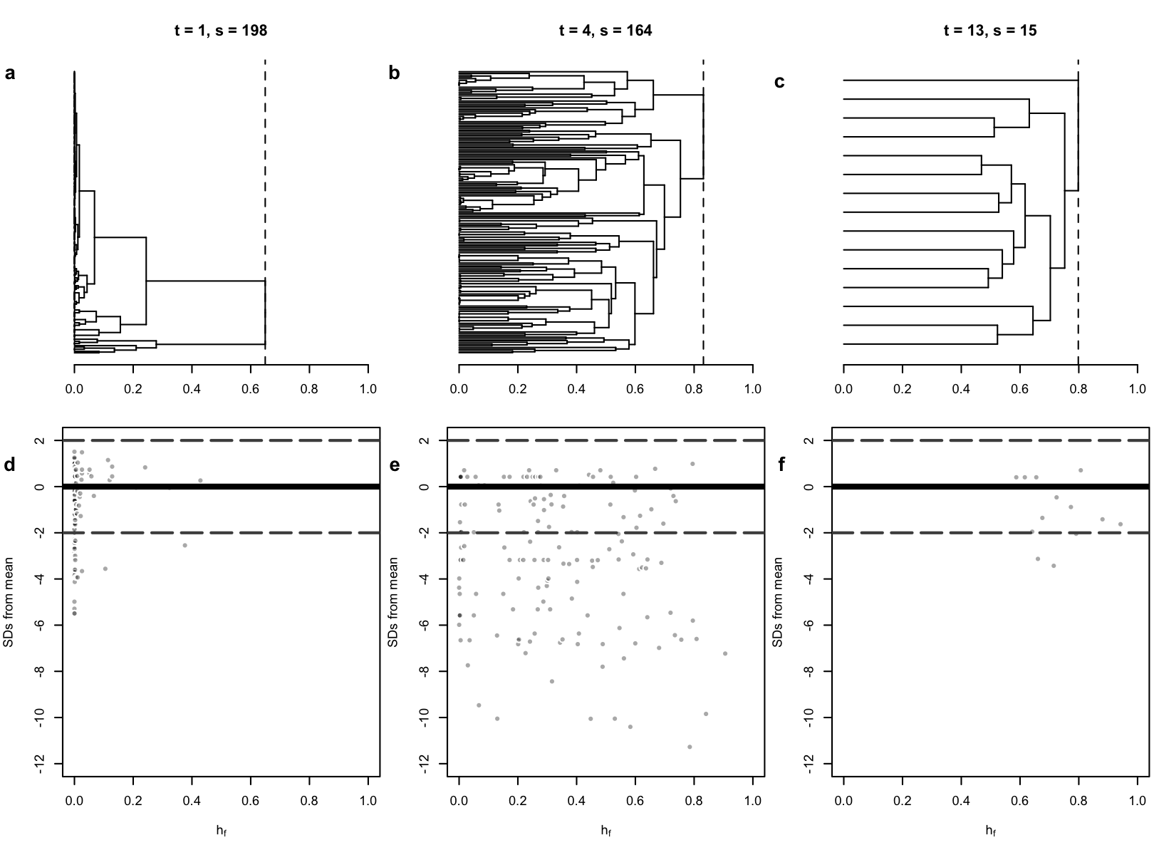

**Figure 3** a-c: Dendrogram structure of different analyses under condition A. *t*  indicates number of traits and *s* indicates number of species included. D-f corresponding standard deviation of node D+ from that expected for the size of the node. Solid line indicates 0 sd from expected. Broken lines delimit ± 2 sd from expected. Points below the -2 sd line indicate nodes containing species which are significantly more taxonomically related than would be expected by chance. Note that the height in plots d-f have been standardized to exclude the root branch (vertical broken lines in a-c).

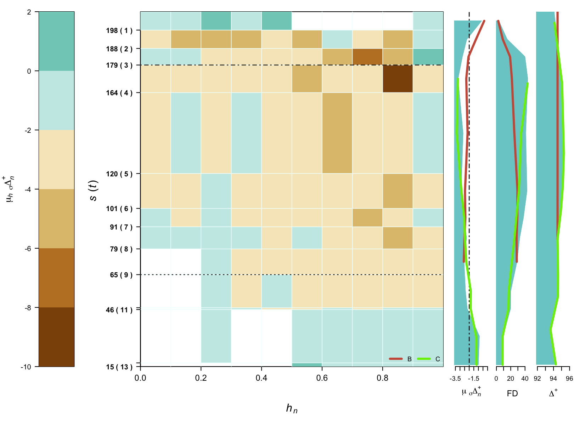

**Figure 4** Trends in m sD+, FD & D+ as a function of varying *s* & *t* combinations under condition A (both *s* & *t* varied according to data availability). Overlaid solid colour lines show trends under conditions B & C for comparison. Image shows the mean intensity of node standard deviation from expected D+ at 0.1 height intervals of dendrograms in each analysis. Heights standardized to exclude root branch as described in figure 3.

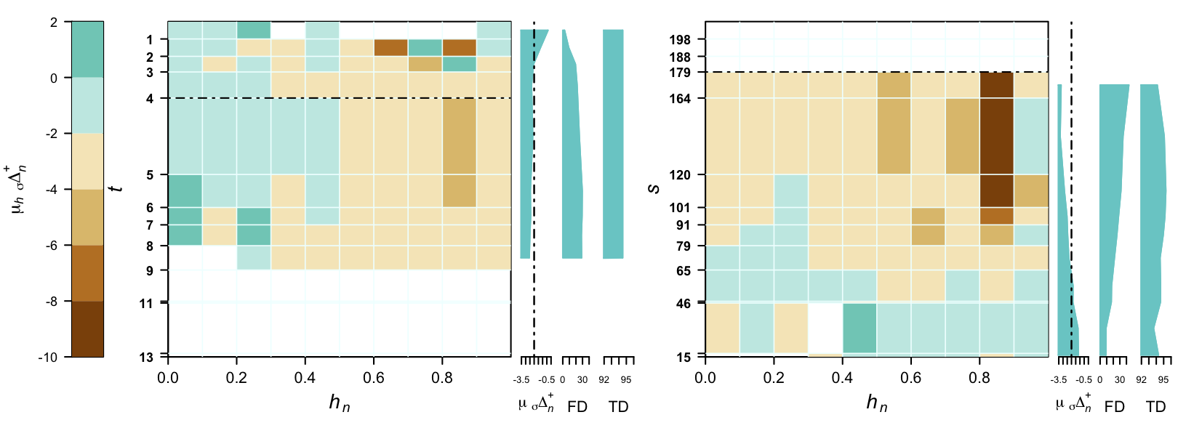

**Figure 4** Trends in m sD+, FD & D+ as a function of varying *s* & *t* combinations under conditions B (*s* = constant at 65) & C (*t* = constant at 4) . Images shows the mean intensity of node standard deviation from expected D+ at 0.1 height intervals of dendrograms in each analysis. Heights standardized to exclude root branch as described in figure 3.

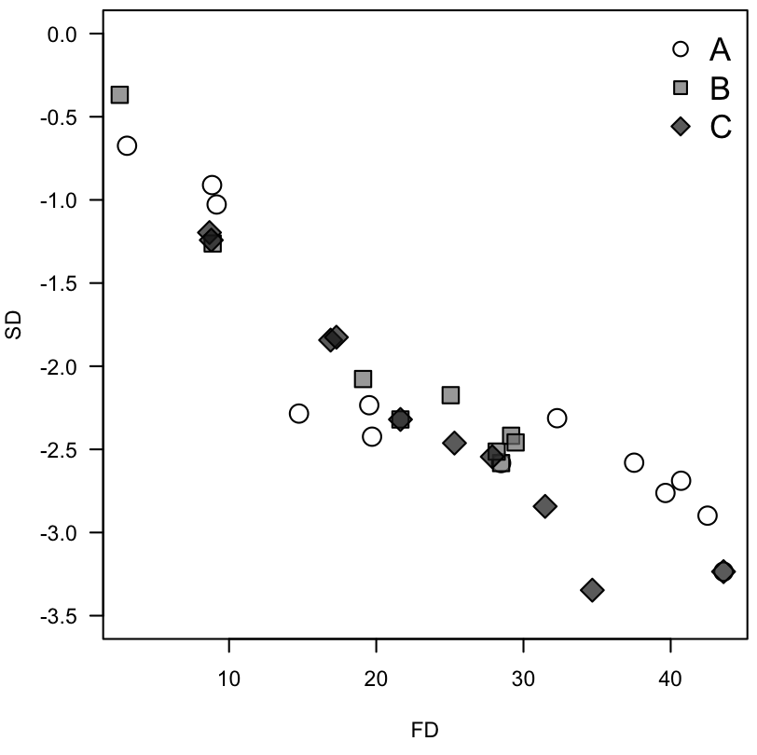

**Figure 6** Relationship between μ σΔ*n*+ and FD across all conditions tested.

1. <http://www.marinespecies.org/> - last accessed 07/09/2013
2. <http://www.marlin.ac.uk/biotic/> - last accessed 07/09/2013